**StreamStockTrend: Real-Time Stock Trend Prediction with LSTM Models on Streamlit Platform**

A Project Report

submitted in partial fulfillment of the requirements

of

Industrial Artificial Intelligence with Cloud Computing

by

**Patel Preetkumar Vinaybhai, 210841102035**

**Tandel Manasviben Upendrakumar, 210841102061**

**Patel Sujal Arunbhai, 210841102037**

**Dalal Kush Jaiminkumar, 210841102010**

Under the Esteemed Guidance of

**Abdul Aziz Md, Master Trainer, Edunet Foundation.**

**ACKNOWLEDGEMENT**

I would like to express my sincere gratitude to all those who have contributed to the completion of this project. Without their support, guidance, and encouragement, this endeavor would not have been possible.

First and foremost, I extend my heartfelt thanks to **Abdul Aziz Md, Master Trainer**, **Edunet Foundation,** whose expertise and mentorship provided invaluable insights throughout the duration of this project. Their unwavering support and commitment played a pivotal role in shaping its outcome.

I am also immensely grateful to **Dr. Latesh B. Chaudhari,** Principal, RNGPIT, and **Mr. V. C. Joshi,** Head of Department, and **Miss. Foram Sukla,** Faculty of Department, Bachelor of Vocation-Software Developmentfor their dedication and contributions at various stages of the project. Their collaborative efforts, feedback, and constructive criticism significantly enhanced the quality and effectiveness of our work.

I would also like to acknowledge the support of and friends, who provided encouragement, understanding, and patience throughout this journey. Their unwavering belief in me served as a constant source of motivation, and for that, I am truly grateful.

Thank you to everyone who contributed in any way, no matter how big or small. Your support has been invaluable, and I am deeply appreciative of the opportunity to work alongside such talented and dedicated individuals.

Sincerely,

Patel Preetkumar Vinaybhai (210841102035)

Tandel Manasviben Upendrakumar (210841102061)

Patel Sujal Arunbhai (210841102037)

Dalal Kush Jaiminbhai (210841102010)

**ABSTRACT**

This study investigates the historical challenges faced by us in the stock market, particularly focusing on personal obstacles such as paperwork and administrative burdens. As a student investor, navigating the complexities of the stock market often involves grappling with cumbersome paperwork requirements, including account setup forms, transaction documentation, and regulatory filings. These administrative tasks can pose significant barriers, consuming time and resources, and impeding students' ability to focus on learning and investment strategies.We implement it by machine learning-based LSTM (Long Short-Term Memory) model. Through LSTM algorithms, the LSTM-UI model generates intuitive indicators, allowing users to easily understand when to buy or hold stocks. Through empirical analysis and user testing, this study demonstrates the effectiveness of the LSTM-UI framework in empowering users with accessible and actionable insights. Through qualitative analysis and experiential insights, this study explores the impact of reducing administrative burdens on learning outcomes in the stock market. We findings the user-friendly solutions to promote financial literacy and facilitate meaningful engagement in the stock market.

**LIST OF FIGURES**

|  |  |  |
| --- | --- | --- |
| **Sr.No** | **Figures Name** | **Page No.** |
|  | Figure 1.3.1 Close time VS Time chart | 8 |
|  | Figure 1.3.2 Close price VS Time chart with 100EMA | 8 |
|  | Figure 1.3.3 Close price VS Time chart with 100EMA & 200EMA | 9 |
|  | Figure 1.3.4 Prediction VS Original | 9 |
|  | Figure 4.1 Close time VS Time chart | 15 |
|  | Figure 4.2 Close price VS Time chart with 100EMA | 15 |
|  | Figure 4.3 Close price VS Time chart with 100EMA & 200EMA | 16 |
|  | Figure 4.4 Prediction VS Original | 16 |

**TABLE OF CONTENTS**

Acknowledgement

Abstract

List of Figures

**Chapter 1.**  **Introduction**  **6**

1.1 Problem Statement 7

1.2 Problem Definition 7

1.3 Expected Outcomes 7

1.4. Organization of the Report 9

**Chapter 2.**  **Proposed Methodology** **11**

2.1 Data Flow Diagram 12

2.2 Advantages 12

2.3 Requirement Specification 13

**Chapter 3. Implementation and Results**  **14**

**Chapter 4. Conclusion**  **17**

**Chapter 5. Future Scope**  **19**

**GitHub Link**...................................................................................................................  **21**

**Video Link**......................................................................................................................  **21**

**References** **22**

**CHAPTER 1**

**INTRODUCTION**

**CHAPTER 1**

**INTRODUCTION**

1. **Problem Statement:**

This study examines the challenges encountered by us, in participating in the stock market, with a focus on administrative hurdles such as paperwork. Historically, engaging in stock market activities has involved burdensome paperwork requirements, including account setup forms, transaction documentation, and regulatory filings. These administrative tasks often consume time and resources, detracting from the overall user experience and limiting participation in investment opportunities.

1. **Problem Definition:**

This study presents an innovative solution to empower users in making informed stock investment decisions using a machine learning-based LSTM model. The proposed framework, termed LSTM-SB (Stock Buy Decision), utilizes LSTM algorithms to generate predicted stock price trends. These predicted trends are visualized as a "hive" or a dynamic line, representing future price movements. Users can leverage this hive to assess the desirability of buying or holding a specific stock. Through extensive experimentation and validation with historical market data, the LSTM-SB framework demonstrates its efficacy in providing valuable insights for stock market participants. By integrating machine learning techniques into the decision-making process, the LSTM-SB model enables users to navigate the complexities of the stock market with increased confidence. This research contributes to advancing the application of LSTM-based machine learning models in financial decision-making and offers a practical tool for enhancing investment strategies.

1. **Expected Outcomes:**

The ultimate objective is to develop a reliable and accurate stock trend prediction system that provides valuable insights to investors, traders, and financial analysts. By leveraging AI and ML technologies, the system aims to enhance decision-making processes in the stock market, mitigate risks, and optimize investment strategies for improved returns.

Keywords: Stock trend prediction, Artificial Intelligence, Machine Learning, Data Analysis, Feature Engineering, Model Development, Model Evaluation, Deployment, Financial Markets.

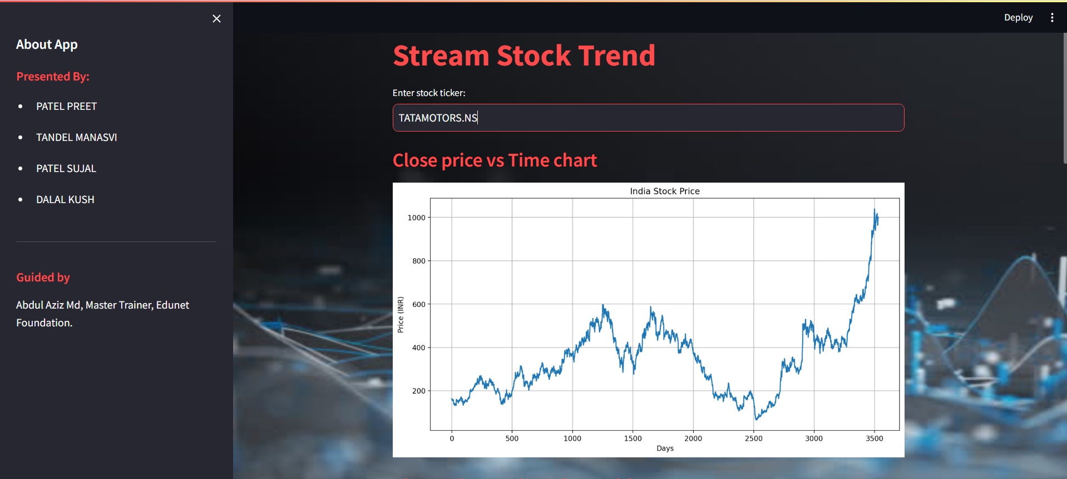Figure 1.3.1 Close time VS Time chart

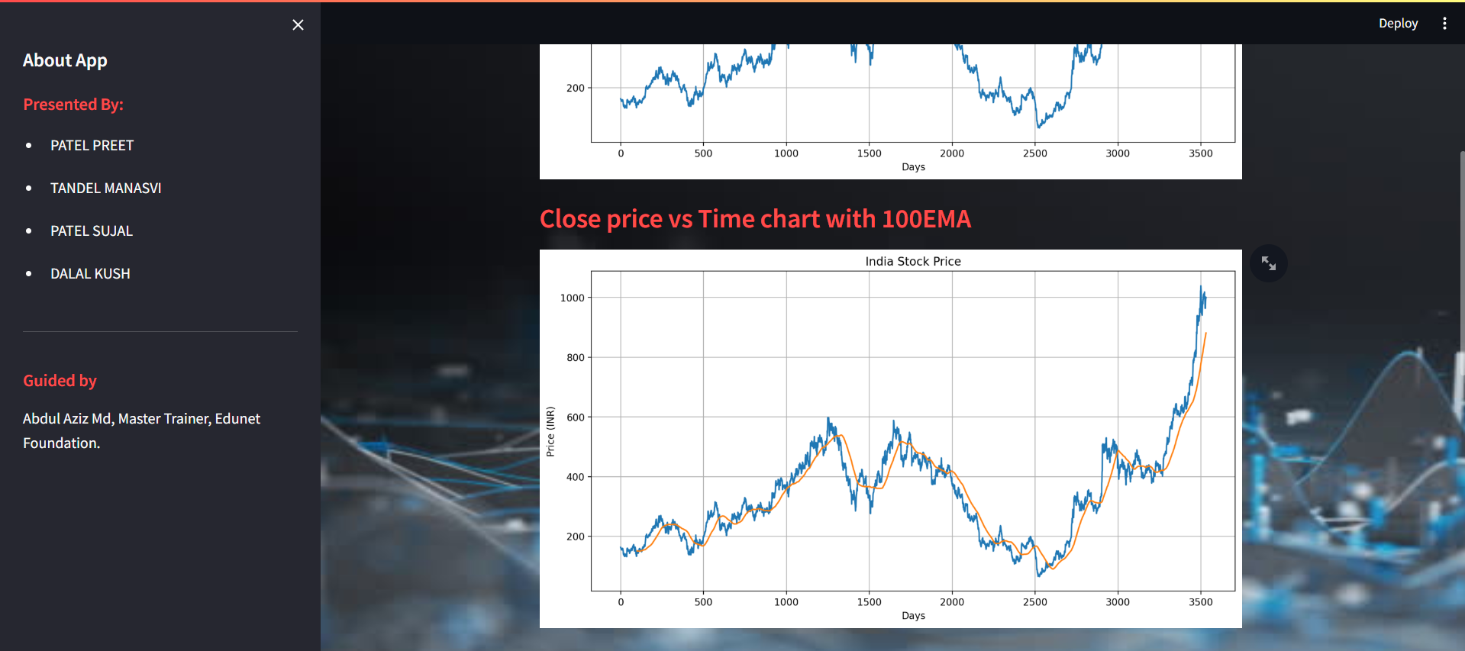Figure 1.3.2 Close price VS Time chart with 100EMA

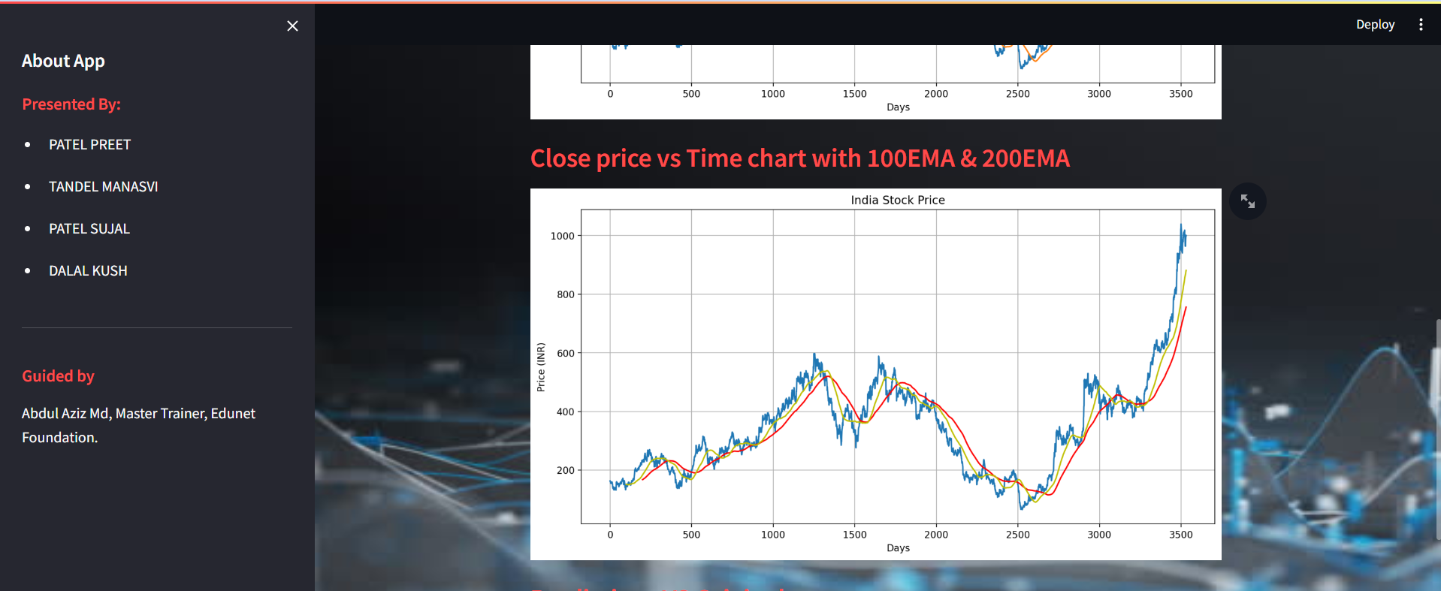Figure 1.3.3 Close price VS Time chart with 100EMA & 200EMA

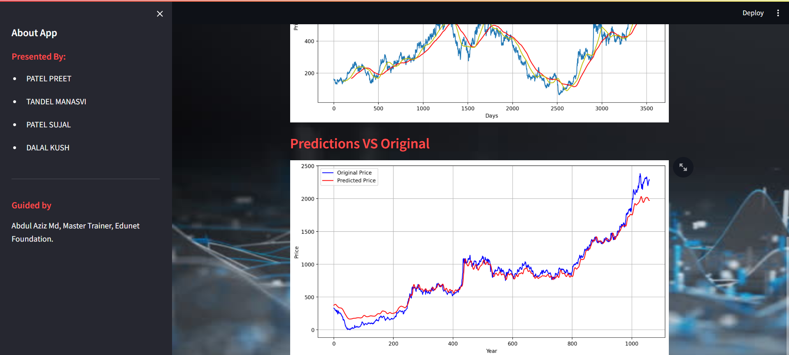Figure 1.3.4 Prediction VS Original

1. **Organization of the Report**

**Chapter 2: Proposed Methodology**

* The proposed methodology flow diagram illustrates the sequential steps involved in developing the system for predicting whether to buy or not buy a stock based on stock trend prediction using AIML techniques. Each step in the flow diagram represents a key stage in the project's lifecycle, from data collection to model evaluation and deployment. Also, it includes the Advantages of techniques and also provide the Requirement specification of hardware and software.

**Chapter 3: Implementation and Result**

* The implementation phase of the project involves translating the proposed methodology into executable code, including data collection, preprocessing, model development, and user interface design. Following implementation, the system's performance is evaluated through testing with historical data, assessing metrics such as accuracy and precision. Results are documented to highlight the system's effectiveness in predicting stock buying decisions based on AIML techniques, offering valuable insights for users navigating the stock market.

**Chapter 4: Conclusion**

* In the conclusion, the project summarizes its successful implementation of a system for predicting stock buying decisions using AIML techniques, highlighting its effectiveness and potential implications for users in the stock market. The future scope section explores avenues for further development, such as expanding features, integrating with trading platforms, and exploring advanced algorithms. References acknowledge the sources consulted during the project, contributing to its completeness and providing resources for further exploration.

**CHAPTER 2**

**PROPOSED METHODOLOGYCHAPTER 2**

**PROPOSED METHODOLOGY**

* 1. **Data Flow Diagram**

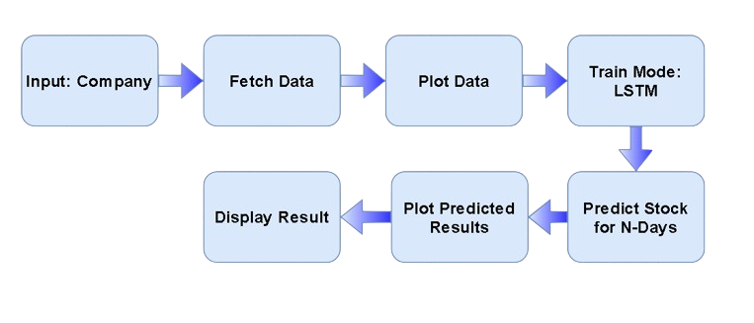

* 1. **Advantages**
* **Improved Accuracy:** AIML algorithms can analyze large volumes of historical stock data and identify complex patterns that human analysts may overlook. By leveraging advanced statistical techniques and pattern recognition capabilities, AIML models can make more accurate predictions of stock price movements.
* **Real-time Insights:** AIML models can process and analyze data in real-time, providing investors and traders with timely insights into changing market conditions and emerging trends. This enables proactive decision-making and the ability to capitalize on opportunities before they are fully reflected in stock prices.
* **Automated Decision Support:** AIML-based stock prediction systems can automate the decision-making process for investors and traders. By integrating with trading platforms or financial systems, these systems can generate buy/sell signals based on predicted stock trends, allowing for faster execution of trades and optimized portfolio management.
* **Scalability:** AIML models can be trained on large datasets encompassing diverse stocks and market conditions, making them scalable to accommodate a wide range of investment strategies and trading preferences. As more data becomes available, AIML models can be continuously updated and refined to improve their predictive accuracy over time.
  1. **Requirement Specification**
     1. **Hardware Requirements:**

|  |  |
| --- | --- |
| **Hardware Requirements** | **Description** |
| CPU | Multi-core processor with a clock speed of 2.0 GHz or higher for efficient computation. |
| GPU | Dedicated Graphics Processing Unit (GPU) with CUDA support for accelerated deep learning tasks. |
| RAM | Minimum 8GB DDR4 RAM for basic AIML tasks; 16GB or more recommended for complex models and larger datasets. |
| Storage | Solid State Drive (SSD) with at least 256GB storage capacity for faster data access and model training. |
| Network Connection | High-speed internet connection with low latency for accessing cloud platforms, downloading datasets, and collaborating on projects. |

* + 1. **Software Requirements:**

|  |  |
| --- | --- |
| **Software Requirements** | **Description** |
| Programming Language | Python or R for data analysis and machine learning tasks. |
| Integrated Development Environment (IDE) | PyCharm, Jupyter Notebook, VS Code |
| Data Processing Libraries | Pandas and NumPy for data manipulation and preprocessing. |
| Machine Learning Libraries | Scikit-learn for machine learning algorithms; TensorFlow or PyTorch for deep learning tasks. |
| Visualization Libraries | Matplotlib and Seaborn for Python. |
| Web Development Frameworks (Optional) | Flask or Django for backend development; HTML/CSS/JavaScript for frontend. |
| Deployment Platforms | Amazon Web Services (AWS), Microsoft Azure for deploying machine learning models. |
| Version Control | Git for version control; GitHub, GitLab, Bitbucket for hosting repositories. |

**CHAPTER 3**

**IMPLEMENTATION AND RESULT**

**CHAPTER 3**

**IMPLEMENTATION AND RESULT**

Figure 4.1 Close time VS Time chart

Figure 4.2 Close price VS Time chart with 100EMA

Figure 4.3 Close price VS Time chart with 100EMA & 200EMA

Figure 4.4 Prediction VS Original

**CHAPTER 4**

**CONCLUSIONCHAPTER 4**

**CONCLUSION**

In conclusion, the development and implementation of this basic level project on stock trend prediction for stock buying decisions using AIML represent a significant step towards understanding the application of Artificial Intelligence and Machine Learning in financial decision-making. Through this project, we have gained valuable insights into the process of analyzing historical stock data and utilizing AIML algorithms to provide actionable recommendations for investors. Our project focused on predicting whether to buy or not based on stock trend predictions, employing simple AIML techniques and LSTM Model. By leveraging AIML to analyze historical stock data and identify patterns indicative of future price movements, investors can mitigate risks and capitalize on opportunities in the dynamic stock market environment.

**CHAPTER 5**

**FUTURE SCOPE**

**CHAPTER 5**

**FUTURE SCOPE**

This basic level project represents just a small step in our journey, it underscores the transformative potential of AIML in revolutionizing financial decision-making. By continuing to learn, experiment, and innovate, we can unlock new possibilities and empower individuals to navigate the complexities of the stock market with greater confidence and efficiency. By analyzing the financial data of the company and other data of the company, using such an algorithm will predict whether the stock should be buy or not.

**GitHub Link**

[**https://github.com/PREETPATEL-3504/Stock-Trend-Predication.git**](https://github.com/PREETPATEL-3504/Stock-Trend-Predication.git)

**Video Link**

[**https://github.com/PREETPATEL-3504/Stock-Trend-Predication.git**](https://github.com/PREETPATEL-3504/Stock-Trend-Predication.git)

**REFERENCES**

1. <https://youtu.be/s3CnE2tqQdo?si=AZ9RFevIqYaNFJs>
2. <https://github.com/034adarsh/Stock-Price-Prediction-Using-LSTM>
3. <https://streamlit.io/components>